Grandview High School Name: __________________________________

Honors Algebra 2

Required Summer Assignment Due Date: **SECOND DAY** OF HALG2 CLASS

**Please complete this assignment and bring it to your second day of Honors Algebra 2 class in August.** These problems require the use of math skills that are pre-requisites for Honors Algebra 2, which means you should feel *very confident* using these skills *before* you start Honors Algebra 2. An assessment over these concepts will be given sometime during the first few days of Honors Algebra 2 class. No calculators allowed.

Part 1: Factoring

Factor each polynomial expression completely. Write down all work as necessary to share your thought process with the reader.

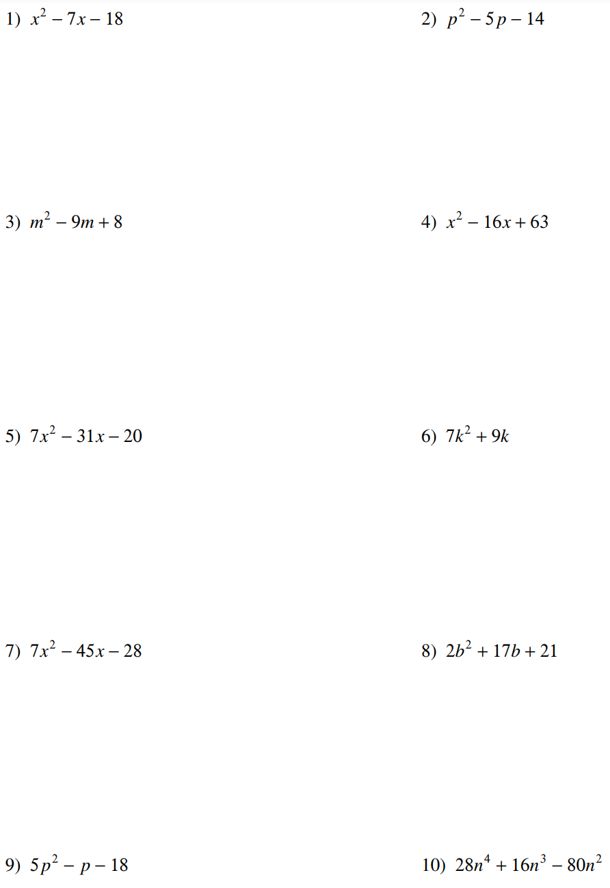

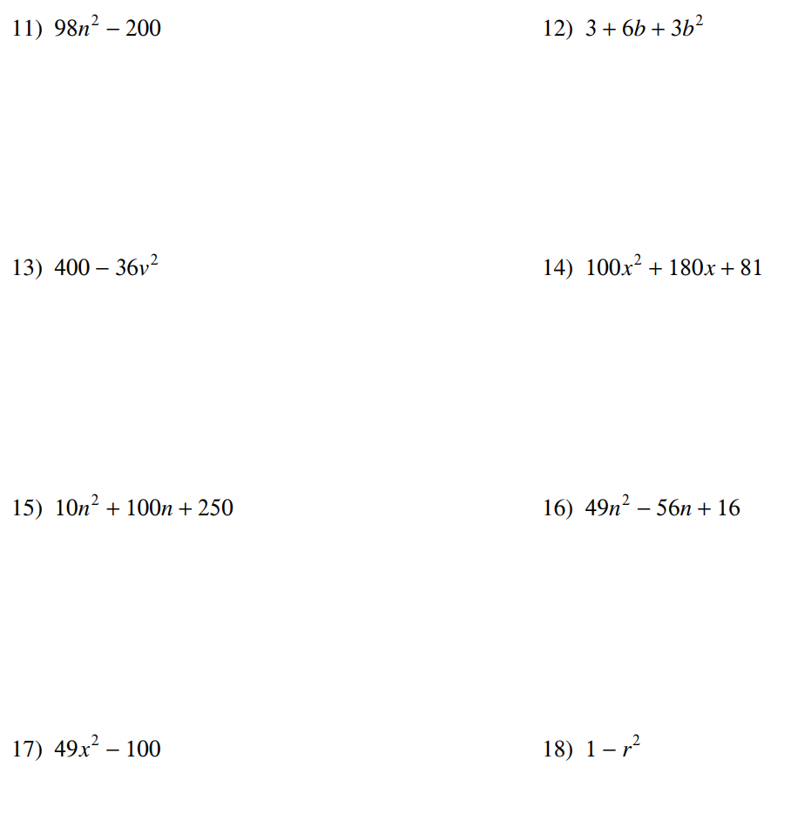

Part 2: Exponent Rules

Use exponent rules to simplify the expressions. The final expression should have only POSITIVE exponents. Write down all work as necessary to share your thought process with the reader.

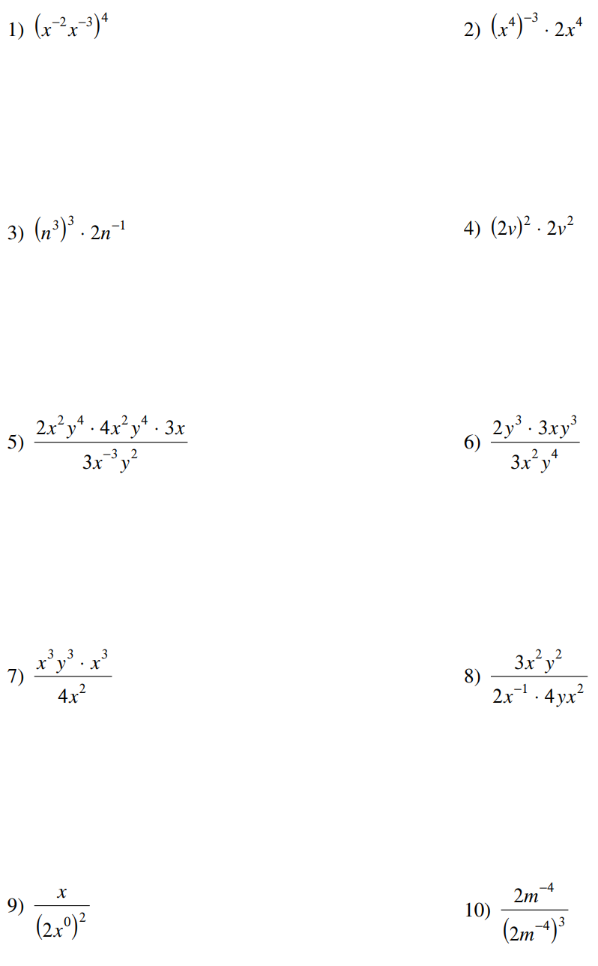

Part 3: Linear Equations and Graphs

Write the equations of the given lines in both A) POINT-SLOPE form ( $y-y_{1)}=m(x-x_{1})$ and B) SLOPE- INTERCEPT form $(y=mx+b)$. Write down all work as necessary to share your thought process with the reader. Assume each box equals one unit.

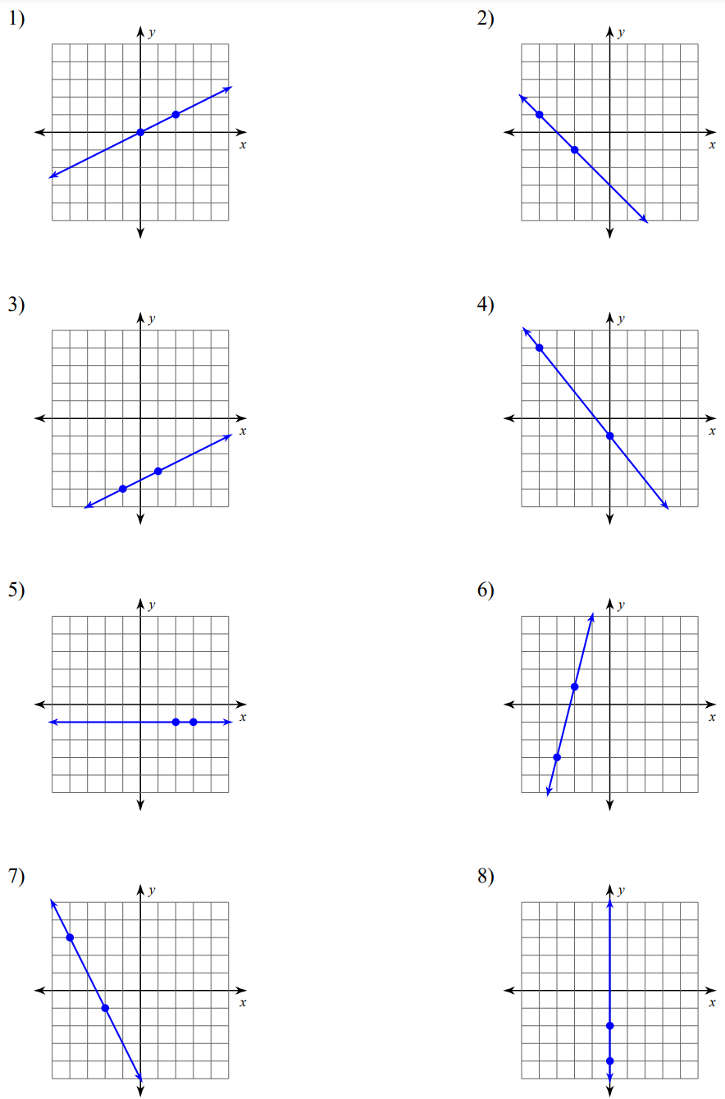

Part 4: Equations and Graphs of Circles

Identify the radius and the center of each circle. Then graph the circle on the coordinate plane provided. When necessary, complete the square and write down all work to share your thought process with the reader.

